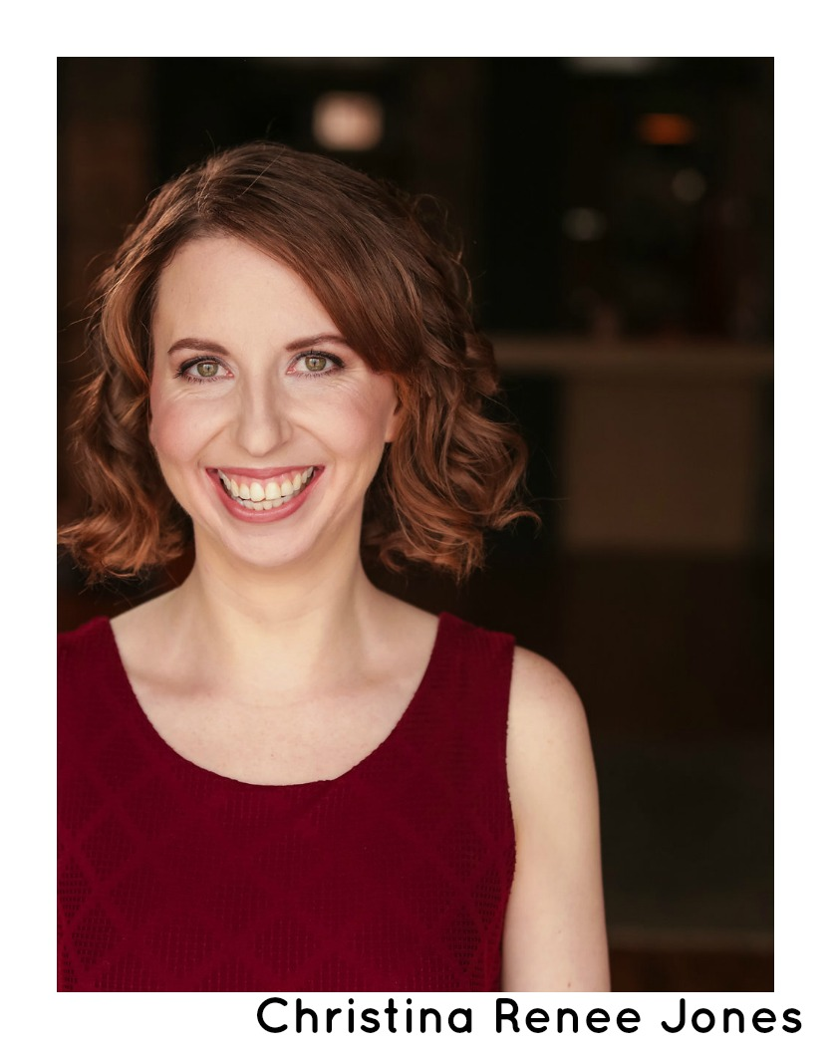
Christina Renee Jones
joneschristinarenee@gmail.com HEIGHT: 5'10"
Cell: (432) 296-3902 EYES: Green HAIR: Auburn
Chicago/Regional Theatre
UPON THIS SHORE: PERICLES Dyonyza Idle Muse Theatre Evan Jackson
IN THE NEXT ROOM Sabrina Daldry Idle Muse Theatre Morgan Manasa
LONELY HEARTS (2018-2021) Julia Birch House Immersive Stephanie Mattos
THE ODE AT PINT’S END The Deep Birch House Immersive Lauren Fields
MACBETH Porter/Doctor Midsommer Flight Beth Wolf
THE SUNDIAL Miss Ogilvie City Lit Theatre Paul Edwards
PEYTON PLACE Kathy/Betty City Lit Theatre Paul Edwards
THE MISANTHROPE Ellen Piccolo Theatre Michael Graham
LADY WINDERMERE’S FAN Lady Agatha Dead Writers Theatre Collective Jim Shneider
THE GAME OF LOVE AND CHANCE Lisette Open Door Repertory Theatre Charlie Marie McGrath
MUCH ADO ABOUT NOTHING Verges Midsommer Flight Beth Wolf
CURSED: AN AMERICAN TRAGEDY Sarah Foster Birch House Immersive Lauren Fields
WHERE WE GO TOGETHER Val Dead Whale Productions Daniella Wheelock
DARK DAY Renee Russell Birch House Immersive Lauren Fields
LYSISTRATA Boeotian the side project Charlie Marie McGrath
THE FOREIGNER Catherine Boston Avenue Playhouse Jay Brown
CHILDREN OF A LESSER GOD Sarah Boston Avenue Playhouse Jim Bush
HAND IN HAND Nina (u/s)** Akvavit Theatre Breahan Eve Pautsch
FOIL Peters Broken Nose Theatre Charlie Marie McGrath
STUDY IN SCARLET Charpentier (u/s) /Lucy (u/s) Promethean Ensemble Paul Edwards
THE MEMORY OF WATER Catherine (u/s)/Teresa (u/s) Piccolo Theatre Michael Graham
CRACKED Snow White The Arc Theatre Derek Bertelsen
TRAUMA Guilt Prologue Theatre Dylan Marks
SUPERHEROINES Domestic Defendress 20% Theatre Company Charlie Marie McGrath
**performed role on September 24th, 2016
Educational Theatre
ANTON IN SHOW BUSINESS Casey Mulgraw Texas Tech University Linda Donahue
EQUUS Jill Mason Texas Tech University Jim Bush
WE WON’T PAY! WE WON’T PAY! Antonia Texas Tech University Troy Lescher
THE TAMING OF THE SHREW Katherina Angelo State University James Worley
LOVE’S LABOUR’S LOST Rosaline Texas Tech University William Gelber
THE MISS FIRECRACKER CONTEST Tessy Mahoney Texas Tech University Alexandra Moore
THE BFG Meatdripper/Mary Texas Tech University Hannah McKinney
CABIN FEVER Pidge Texas Tech University Jen Watson
LONE STAR LOVE POTION Tammy Jo Harper Texas Tech University Shane Roberie
XSR: DIE! Rosemary Angelo State University James Worley
Education and Training
Physical Improvisation & Acting Technique (Chicago)- Ryan Bruce
Texas Tech University
Acting- Dr. Jonathan Marks, Dr. Bill Gelber, Dr. Jim Bush, Dr. William Doll
Special Skills
Dialects- British RP, Various American Southern, Cockney, French, Irish, Scottish
Physical Activity- Basic fight choreography (slaps, pratfalls, punches, hair drags/pulls, clowning), Roller Skating, Basketball (10 yrs)

